Asbestos Management Plan
The Health and Safety at Work (Asbestos) Regulations 2016 require an up-to-date Asbestos Management Plan for a workplace where asbestos or asbestos-containing material (ACM) is identified, or is likely to be present.
A Person Conducting a Business or Undertaking (PCBU) with management or control of the workplace must ensure that a written plan is prepared. The regulations specify what information must be in the plan.
You can use this template to develop an Asbestos Management Plan. (Note: A separate demolition and refurbishment survey is required to identify asbestos before demolition or refurbishment is carried out at a workplace).
Questions 1–7 must be completed.
The plan should help you to keep everyone healthy and safe. Keep it short, simple and easy to understand.
It must be easy for the following people to access:
- workers and their representatives (such as Health and Safety representatives), and
- PCBUs working, or requiring work to be carried out, at the workplace.
WorkSafe information:
Asbestos management plans
Management and removal of asbestos

You must engage and consult with workers when you are identifying hazards
and working out how to manage risks.

The workplace
If asbestos or asbestos-containing material (ACM) is identified at your workplace, a PCBU with management or control of the workplace must make sure that both the presence and the location of asbestos are clearly indicated. If the building owner and the tenant/s share management and control of the workplace, then they share the overlapping duty to prepare the Asbestos Management Plan.
This Asbestos Management Plan covers the management of asbestos and any asbestos-containing material (ACM) at:
Business name and street address of workplace

If your organisation has other physical addresses (workplaces in a different location to the one above)
you need to prepare site-specific documents for each location.

PCBU with management or control of the workplace
This could be the building owner, who should know where asbestos or ACM is located in the building or structure.
Name: | Type here
Position/job title: | Type here
Email: | Type here
Mobile phone: | Type here

Plan preparation and review

Plan prepared by
Name: | Type here
Position/job title: | Type here
Email: | Type here
Mobile phone: | Type here

Date: | Click here to enter a date or click the drop-down arrow
Version: | Type here

Reviewing and revising this plan
The PCBU with management or control of the workplace must review and (if necessary) revise this Asbestos Management Plan if:
- an asbestos control measure is reviewed
- asbestos at this workplace is removed, disturbed, sealed or enclosed
- five years have passed since the plan was last reviewed
- the plan is no longer adequate for managing the asbestos risks, for example, if new asbestos is identified or a previously inaccessible area is now accessible
- a worker representative requests a review under regulation 14 of the Health and Safety at Work (Asbestos) Regulations 2016

Date/s this plan has been reviewed/revised:
Click here to enter a date or click the drop-down arrow
Click here to enter a date or click the drop-down arrow
Click here to enter a date or click the drop-down arrow
Click here to enter a date or click the drop-down arrow
Click here to enter a date or click the drop-down arrow

Identification of asbestos or Asbestos-Containing Material (ACM)
Identify where asbestos/ACM is found, or is likely to be found, in your workplace, for example, in which wall, room, building or other structure.
- You can also attach photos, drawings or site plans that show where the asbestos is located.
(Insert or attach documents to this plan. See the site plan example on the last page of this template.)
- Include any places where the asbestos is not easily reached.
Fill out the table on the following page/s, including details about the decisions, and reasons for decisions, about how the risk of exposure to asbestos/ACM is managed.
If you don’t know which buildings, structures or products at your workplace contain asbestos/ACM, or where it is located, it is recommended that an asbestos survey be carried out by a competent person such as an asbestos surveyor or licensed asbestos assessor.
WorkSafe information:
Managing asbestos risks
A-Z of products that may contain asbestos

BUILDING OR STRUCTURE CONTAINING ASBESTOS/ACM  Provide as much detail as possible, such as which wall or room on what level. | PRODUCT/  ITEM CONTAINING ASBESTOS/ ACM | TYPE OF ASBESTOS/ACM | ESTIMATED VOLUME  OR AREA | FRIABLE OR  NON-FRIABLE? |  | DESCRIBE CONDITION | HOW RISK OF EXPOSURE TO ASBESTOS/  ACM WILL BE MANAGED  What control measures will be used (e.g. removal; encapsulation; sealing; enclosure)? | REASONS  Explain why each control measure was chosen.  If no action  is required,  explain why. | TIMEFRAME FOR COMPLETION  (DD/MM/YYYY) | METHOD OF IDENTIFICATION  How was the asbestos/ACM identified?  - Asbestos survey (attach a paper copy or an electronic copy to the back of this form)  - Assumption  - Other method (explain below, for example: asbestos is indicated  on building plans).
 |  |  |  | Friable | Non-friable
Plant Room 1  Ground Floor  Steel Pipe Factory – main building, 555 Korowai Ave, Rilburne | Compressed wall sheeting | White (chrysotile) | 34 sq meters | ☐ |  | Good condition, painted, no damage evident | No control measure needed as very low risk of exposure | No action needed because asbestos is stable and unlikely to be damaged | 10/10/24  Review due five years after plan developed | ☐ Assumption  ☐ Asbestos survey  (attach copy to back of form)  Other method  Indicated on building plan
Level 2 Copier Room  Inkmo Print  210 Snoote Street Wellington | Behind wall with  tall windows | Type unknown – assumed | 20 sq meters | ☐ |  | Unknown | No control measure needed as very low risk of exposure | No action needed because asbestos is stable and unlikely to be damaged | 10/10/24  Review due five years after plan developed | Assumption  ☐ Asbestos survey  (attach copy to back of form)  ☐ Other method  If other is selected, please type here

BUILDING OR STRUCTURE CONTAINING ASBESTOS/ACM | PRODUCT/ ITEM CONTAINING ASBESTOS/  ACM | TYPE OF ASBESTOS / ACM | ESTIMATED VOLUME  OR AREA | FRIABLE OR  NON-FRIABLE? |  | DESCRIBE CONDITION | HOW RISK OF EXPOSURE TO ASBESTOS/ ACM WILL BE MANAGED | REASONS | TIMEFRAME FOR COMPLETION | METHOD OF IDENTIFICATION
Type here | Type here | Type here | Type here | ☐ | ☐ | Type here | Type here | Type here | Click here to enter a date or click the drop-down arrow  Type here | ☐ Assumption  ☐ Asbestos survey  (attach copy to back of form)  ☐ Other method  If other is selected, please type here
Type here | Type here | Type here | Type here | ☐ | ☐ | Type here | Type here | Type here | Click here to enter a date or click the drop-down arrow  Type here | ☐ Assumption  ☐ Asbestos survey  (attach copy to back of form)  ☐ Other method  If other is selected, please type here
Type here | Type here | Type here | Type here | ☐ | ☐ | Type here | Type here | Type here | Click here to enter a date or click the drop-down arrow  Type here | ☐ Assumption  ☐ Asbestos survey  (attach copy to back of form)  ☐ Other method  If other is selected, please type here
Insert more rows by right-clicking the table and selecting Insert | Type here | Type here | Type here | ☐ | ☐ | Type here | Type here | Type here | Click here to enter a date or click the drop-down arrow  Type here | ☐ Assumption  ☐ Asbestos survey  (attach copy to back of form)  ☐ Other method  If other is selected, please type here

How are you indicating the presence and location of asbestos/ACM to the people at this workplace who need to know that it is there? For example, people whose work could expose them to respirable asbestos fibres?
You can choose how to indicate that asbestos/ACM is present and where it is. For example, make an asbestos record, put a sign on the nearest door, use labels, or mark it on a site plan (see the example on the last page of this template). Make sure people know where to find this information, or are given it before they start work.
Type here

WorkSafe information:
Meeting the duty to indicate the presence and location of asbestos at work

Procedures for managing incidents or emergencies involving asbestos or ACM
How will incidents or emergencies involving asbestos/ACM be managed?
Action | Name and role of person/s responsible
For example, stop work immediately, secure and evacuate work area, contact site manager. Add additional steps — see your workplace emergency plan for details.
Type here | Type here
Insert more rows by right-clicking the table and selecting Insert | Type here

WorkSafe information:
Workplace emergency plans

Main contact person/s for incident/emergency management (eg site manager, facilities manager)
Name: |  | Type here
Position/job title: |  | Type here
Email: |  | Type here
Mobile phone: |  | Type here

Name: |  | Type here
Position/job title: |  | Type here
Email: |  | Type here
Mobile phone: |  | Type here

Procedures for recording details of incidents or emergencies involving asbestos or ACM
After you have handled an incident or emergency, make sure that everyone at the workplace knows what happened and how to prevent a similar event happening again.
How and where will information about incidents or emergencies be recorded?
For example, in a database or other electronic record, in a risk register, in a site diary or notebook.
Type here

Workers carrying out work involving asbestos – information and training
The information and training workers require will depend on the work to be done, how much supervision workers need, the type of asbestos in your workplace, and the risk of exposure.
Licensed asbestos removal work can only be carried out by a licensed removalist who has completed certified training.

Information and training

What information and training has already been provided to workers carrying out asbestos-related work?
For example: asbestos awareness training; safe work methods; site-specific instructions, what PPE equipment is required (see Section 14 of Management and removal of asbestos)
Type here

What information and training is still to be provided to workers carrying out asbestos-related work?
For example: asbestos awareness training; safe work methods; site-specific instructions.
Type here

WorkSafe information:
Training for workers doing work involving asbestos (excluding licensed asbestos removal workers)

Work with asbestos/ACM should be supervised so that it is carried out safely. Supervisors should:
- check that workers have -`site awareness’ – including knowing the locations of asbestos/ACM indicated in this Asbestos Management Plan, so they can avoid disturbing asbestos in or near the work area
- explain what to do in an emergency involving asbestos.

Workers’ roles and responsibilities
  - Identify each worker (for example employee) carrying out work involving asbestos/ACM. Briefly describe each worker’s role and responsibilities. For example: boiler room maintenance; plumbing work involving pipes and lagging.
Note: If the worker is a contractor or sub-contractor, then enter their details in section (B) below.

Name | role (title/position) | RESPONSIBILITIES (TASKS/MAIN ACTIVITIES)
Rob Smith | Caretaker | Boiler room maintenance
Type here | Type here | Type here
Type here | Type here | Type here
Insert more rows by right-clicking the table and selecting Insert | Type here | Type here
  - Identify each contractor or sub-contractor carrying out work involving asbestos/ACM. Briefly describe their role and responsibilities. For example: electrician replacing the switchboard panel; technician working in lift shaft.
This information must be updated each time a contractor or sub-contractor is working on your site.
Name on site | role (Title/position) and company | RESPONSIBILITIES (TASKS/MAIN ACTIVITIES) | dates: FROM/TO
Mary Ng | Electrician | Working on main fuse-board | 10/10/19 to 12/10/19
Type here | Type here | Type here | Type here
Type here | Type here | Type here | Type here
Insert more rows by right-clicking the table and selecting Insert | Type here | Type here | Type here

Worker health monitoring
Note: The requirement for worker health monitoring applies only to certain workplaces. Health monitoring must be provided for workers who may be exposed to asbestos while carrying out certain types of asbestos-related work.
Get advice about whether health monitoring is required for workers, taking into account:
- their exposure to asbestos/ACM
- how long they have been exposed to it
- the type of work that they do;
- the level of risk or potential risk to health and safety;
- whether respiratory protective equipment (RPE) is being used to manage risk.
An occupational hygienist on the HASANZ Register can provide advice.

If health monitoring is required for your workers, what health monitoring has been – or will be – carried out?
Type here

WorkSafe information:
Health monitoring

You can choose whether or not to include more information
It’s good practice to keep written notes about asbestos-related results, records or other documents relating to this plan. For example: schedules for completing asbestos work, air monitoring test results, asbestos survey results, training records.

You can add photos, site plan/s (remove or replace the following example), or other relevant documents here. Link to electronic files or attach printed or photocopied records.
To attach a Word or PDF document click Insert > Object > Text from File
For more information on inserting a Word or PDF document, visit office.com

Other comments/information:
Type here

Example of site plan indicating locations of asbestos
Building address: 555 Korowai Avenue, Rilburne
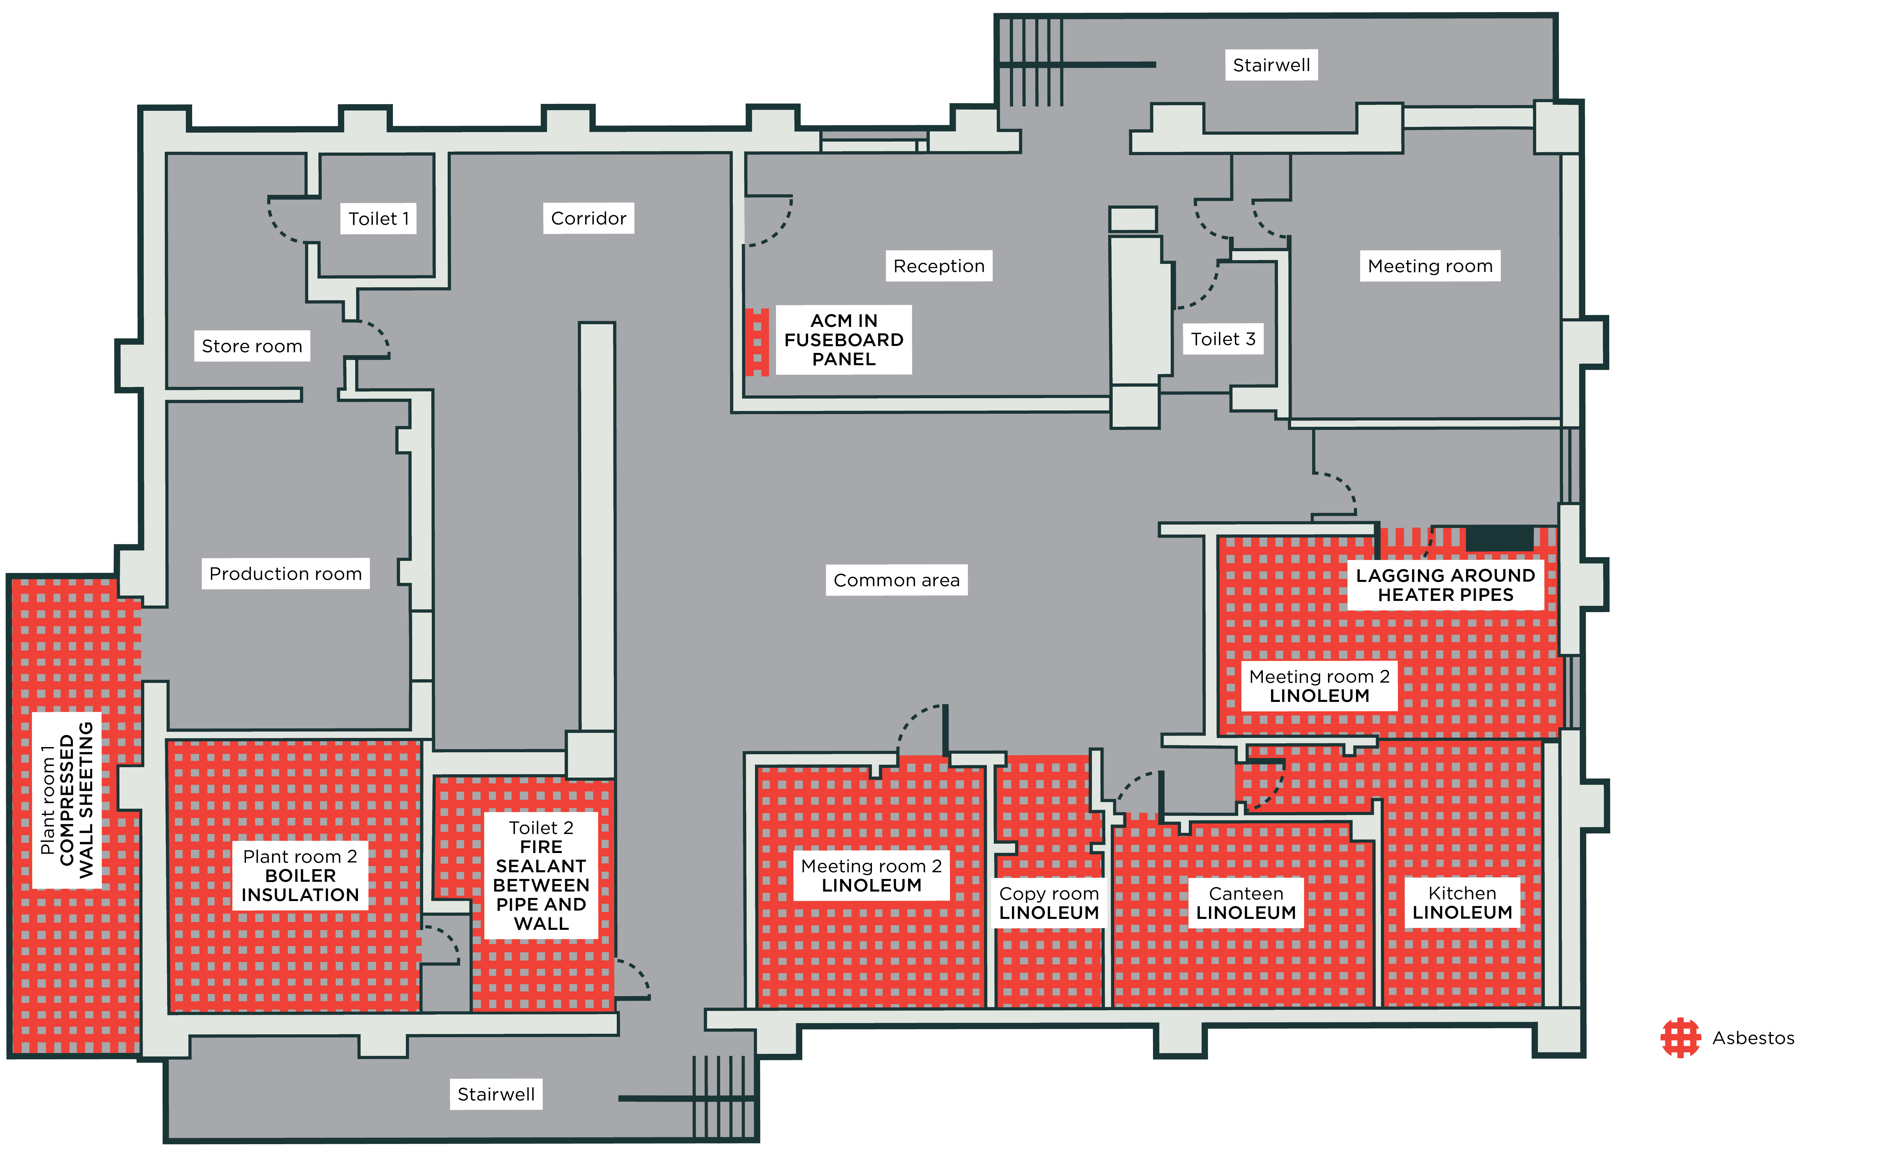

Friable asbestos is in powder form, or able to be crumbled, crushed, or reduced to a powder by hand pressure when dry.
Non-friable asbestos is not in powder form, and is not able to be crumbled, crushed, or reduced to a powder by hand pressure when dry. It includes asbestos and ACM containing asbestos fibres reinforced with a bonding compound, such as asbestos cement sheet in good condition.

