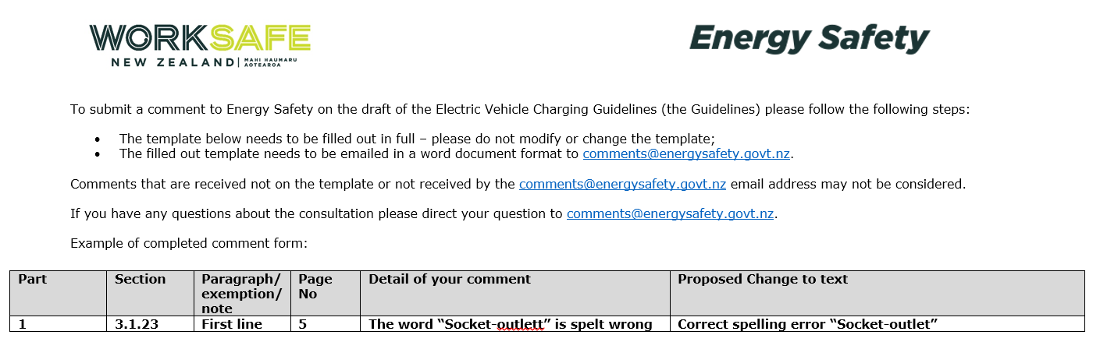

Part | Section | Paragraph/ exception/ note | Page No | Detail of your comment | Proposed Change to text

